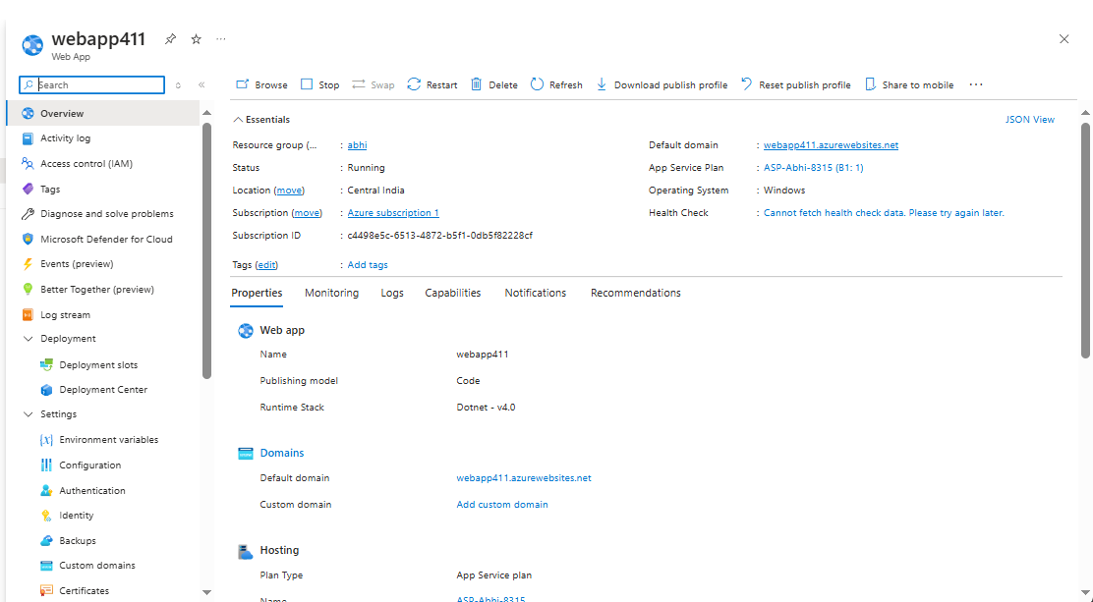

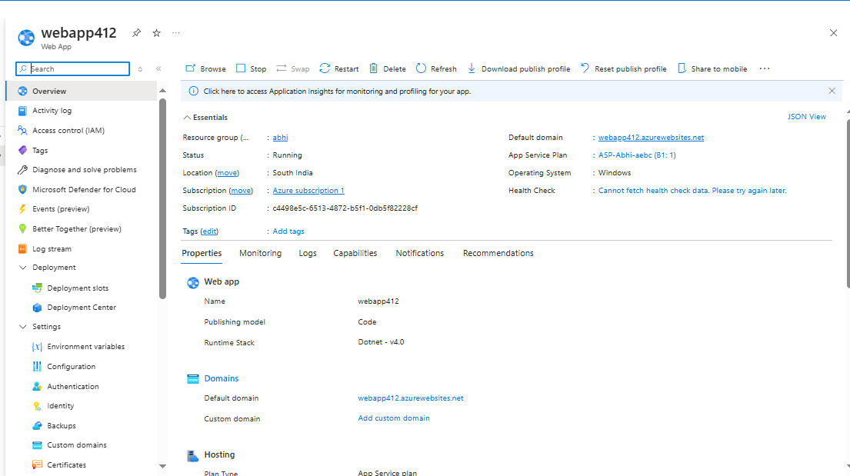

* **Create two web app in two different region**
* **In this I had created two web app one at Central India and the next one at South India**

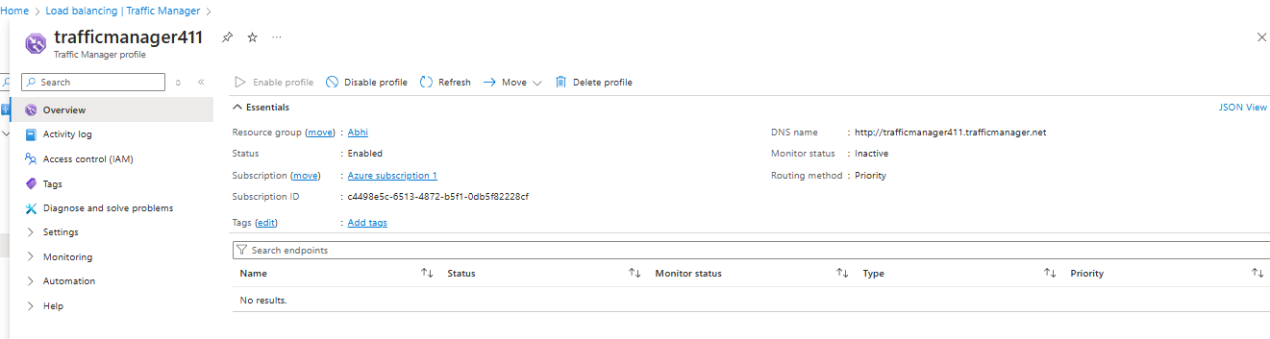

* **We need to purchase domain name from DNS for example : godady, opendns, developers etc**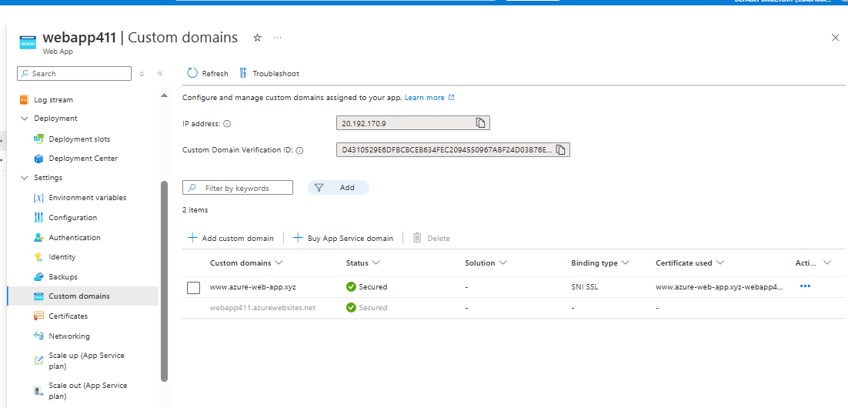
* **In the web app we need to create the custom domains**

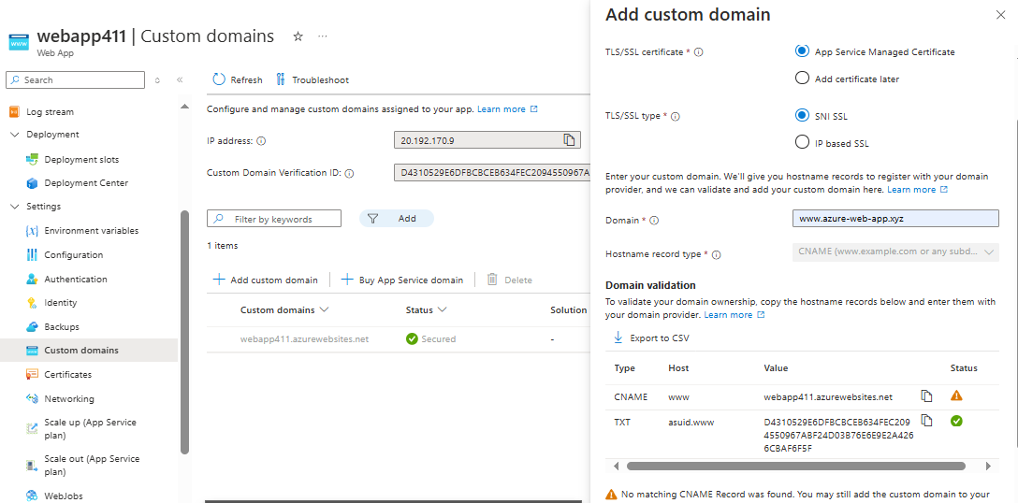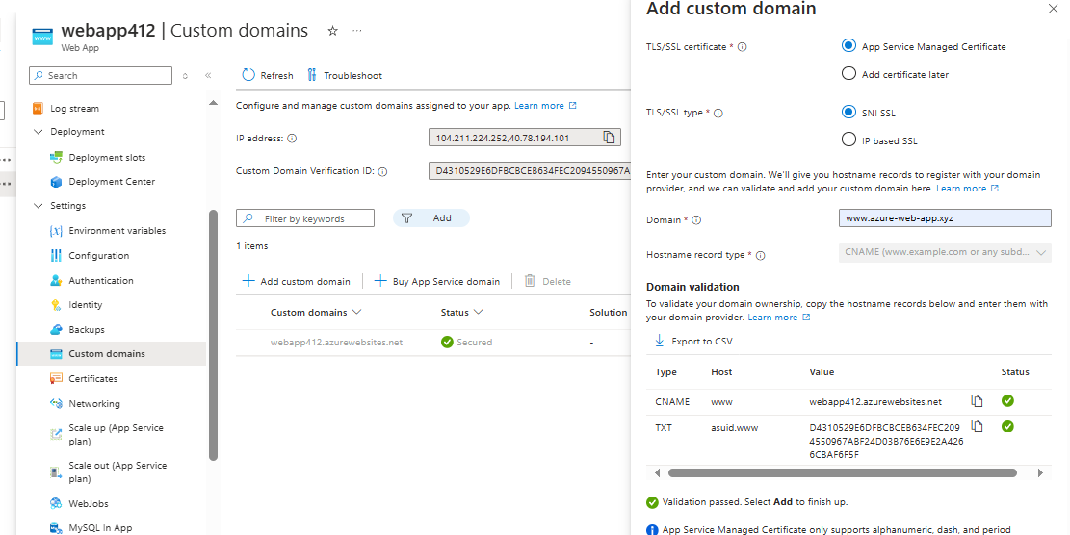

* **In both the web app we need to create the custom dome**
* **For that select add custom domain option**
* **Then select the TLS/SSL type as SNI SSL**
* **Add the domain (**[**www.azue-web-app.xyz**](http://www.azue-web-app.xyz)**)**
* **Then validate it and then add that domain**
* **After creation check the website**

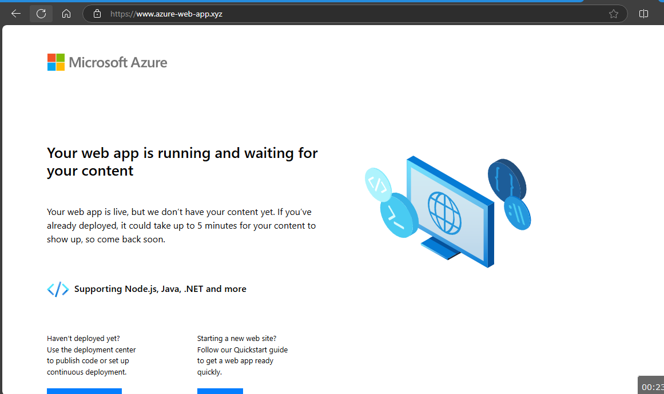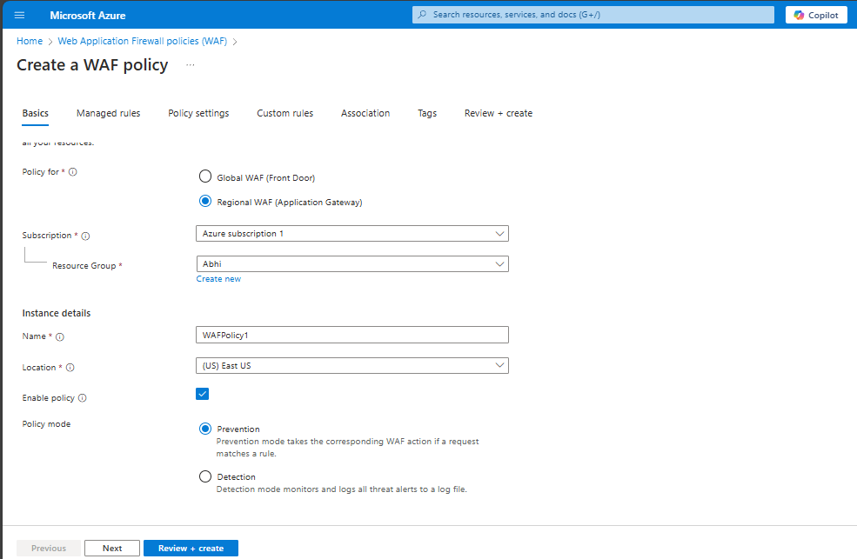

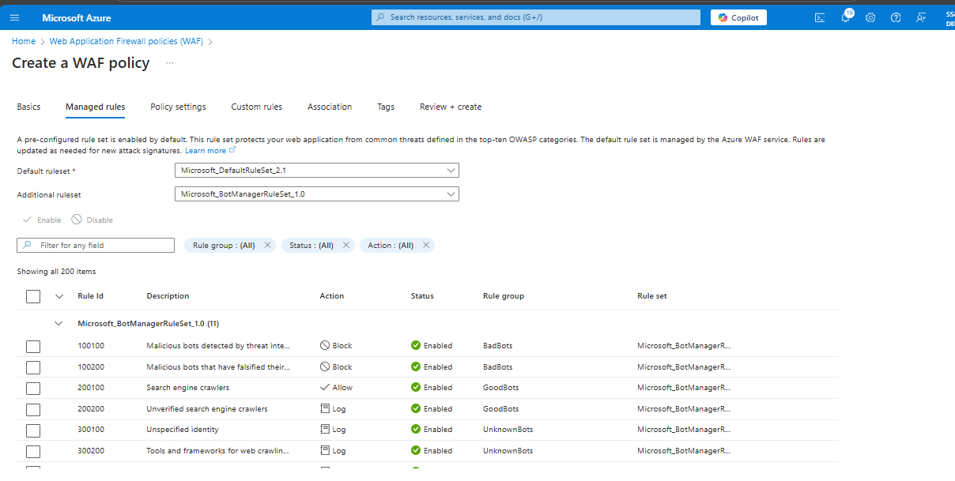

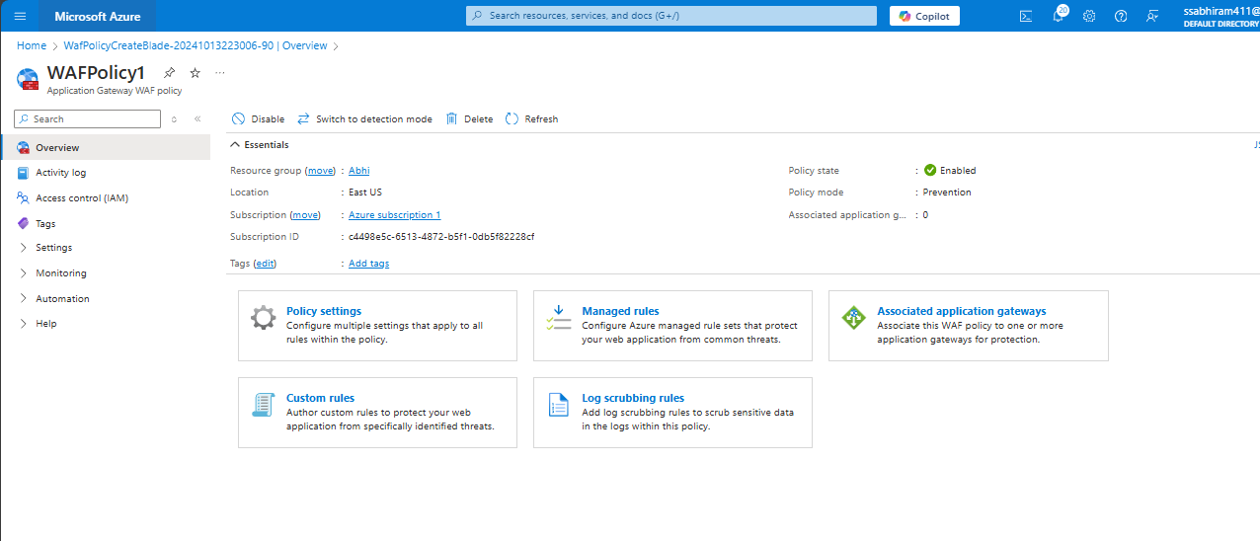

* **We need to create the WAF policy**
* **Add the resource group policy mode etc**
* **The in the manage rules select as default**
* **And then review and create the WAF policy**

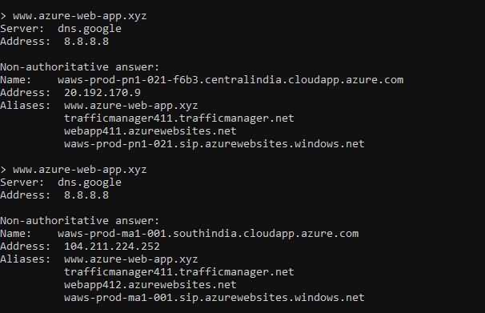

* **After the creation we need to check the domain name from the CMD**
* **Then the current website will get displayed**
* **After the web attack or any server issue occurs it will change in the next region web app**
* **That is what shown in the next line as the web app is changed in the next region**